Full Stack E-Commerce App

Creating a package.json file
Npm init -y

install Backend backaging
npm i express@5.2.1 dotenv@16.4.7 cors@2.8.5 @clerk/express@2.1.0 @clerk/backend@3.2.8 @imagekit/nodejs@7.4.0 @sentry/node@10.48.0 @sentry/profiling-node@10.48.0 drizzle-orm@0.39.3 pg@8.13.1 standardwebhooks@1.0.0 stream-chat@8.57.6 zod@3.24.2
npm i --save-dev @types/express@5.0.6 @types/node@22.10.10 @types/pg@8.11.10 drizzle-kit@0.30.4 tsx@4.19.2 typescript@5.7.3
search this in goole then follw it = creating backend environment using typescript
create tsconfig.json and copy past the env
create the file structure format src/routes , src/middlware , src//controller , src/db , src/ lib .. and index.ts

creating env under route and setup the p[roject env = database , auth
💫 Try Sentry for FREE: https://dub.sh/sentry3
(Get $80 for FREE) 🚀 Try Stream for FREE: https://dub.sh/getstreamio
✨ Try Neon for FREE: https://dub.sh/neon3
🔐 Try Clerk for FREE: https://dub.sh/clerk3
💥 Try Imagekit for FREE: https://tinyurl.com/4c8pmh88
*SENSITY FOR TRACKING ERROR , LOGGIN ....
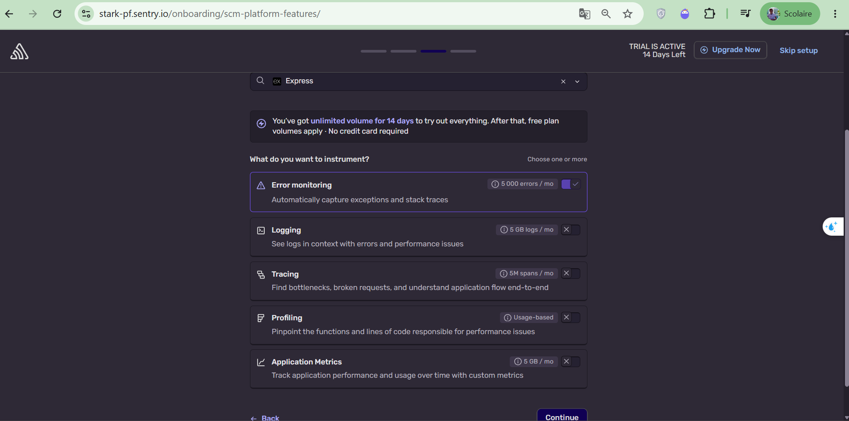
F
*stream for real chating vidio call ...
https://getstream.io/?utm_source=youtube&utm_medium=devrel&utm_content=&utm_campaign=burakq2

*image kit = https://imagekit.io/dashboard

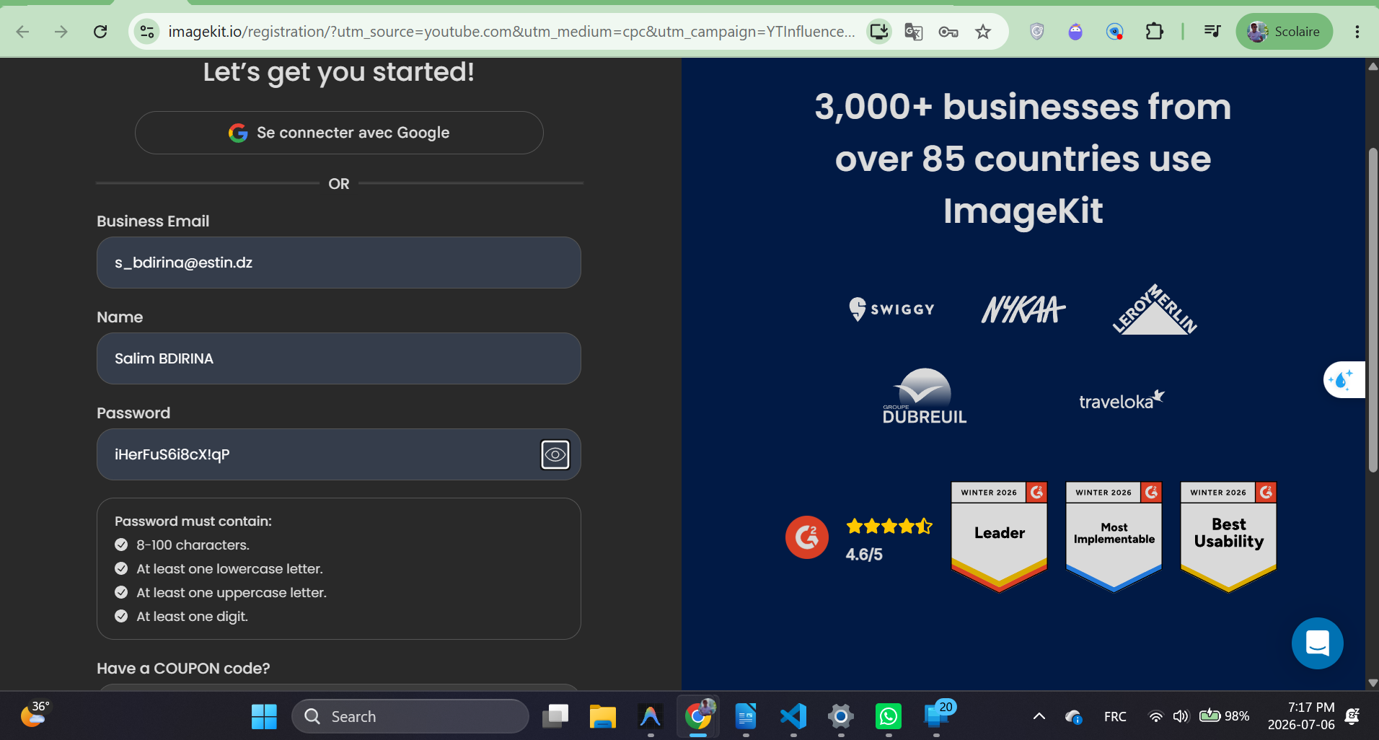
s
we create a dist file that contain the code convert from js to ts
* start server in index.ts
* creat repo and save our work 1 under root we creat .gitignor
git init

